Square = 10

Pentagon = 5

Circle = 2

40+6+ 15 = 61



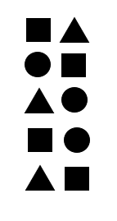





4+15+50= 69

30 + 6 + 20 = 56